The vitamins and minerals in chicken feed and their effects.
Poultry feed needs to contain macronutrients like proteins, fats, carbohydrates and micronutrients such as vitamins and minerals.
Providing a well-balanced diet that includes the essential vitamins and minerals can benefit chickens in various ways:
Promotes overall health and well-being: Vitamins and minerals play a crucial role in maintaining good health and well-being in chickens. A well-balanced diet can help prevent various health problems and promote optimal growth and development.
Improves egg quality: Providing the necessary vitamins and minerals can improve egg quality, including shell thickness, yolk colour, and albumen quality.
Supports growth and development: Vitamins and minerals are essential for growth and development in chickens. Providing a well-balanced diet can help young chickens develop properly and reach their full potential.
Boosts immune system function: Vitamins and minerals are essential for a healthy immune system. Providing the necessary nutrients can help chickens fight off diseases and infections.
Nutrient absorption: Vitamins and minerals are crucial for proper digestion and nutrient absorption. Providing a well-balanced diet can help prevent digestive problems and ensure optimal nutrient uptake.
A lack of micronutrients in the diet is called a deficiency.
Below: Hens eating layer pellets formulated to contain all the minerals and vitamins a chicken needs.
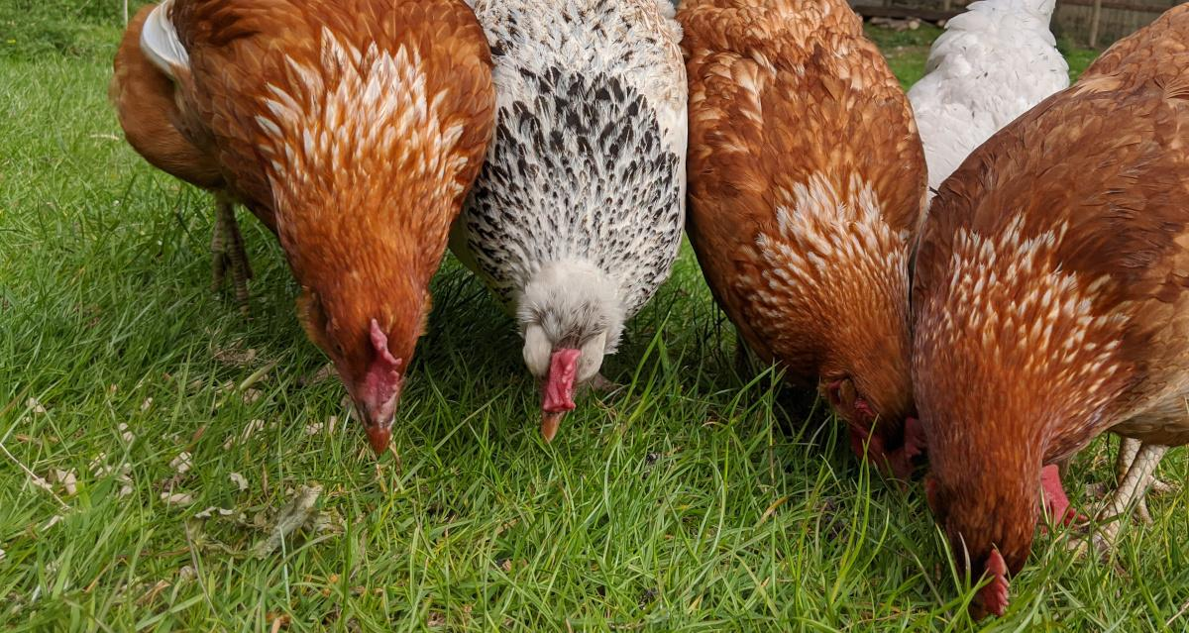
Minerals are inorganic compounds that are essential for various physiological functions. Chickens require minerals for bone health, muscle function, nerve function, and overall health.
Vitamins are essential nutrients that cannot be synthesised by the body in sufficient quantities and therefore must be obtained from the diet.
Vitamins are divided into two groups: fat-soluble vitamins and water-soluble vitamins.
- Fat-soluble vitamins (vitamins A, D, E, and K) are stored in the body's fat tissues and can be toxic in high doses.
- Water-soluble vitamins (vitamin C and the B vitamins) are not stored in the body and must be consumed regularly.
Vitamins are vital amines needed for many bodily processes.
Vitamin / Mineral | Effects and uses in the body. | Result of deficiency
Vitamin A | Vitamin A is essential for vision, growth, and immunity. Chickens can obtain vitamin A from green leafy vegetables, yellow vegetables, and fruits. | - Decreased growth rate.  - Respiratory issues.  - Poor feather quality.  - Night blindness.  - Reduced egg production.
Vitamin D | Needed for calcium and phosphorus absorption and bone health. Chickens can obtain vitamin D from sunlight or through their diet. It also plays a role in egg production and the development of healthy feathers. | - Weak or brittle bones.  - Reduced eggshell quality.  - Slowed growth.  - Leg deformities.
Vitamin E | Vitamin E is an antioxidant that protects cells from damage and is essential for muscle and immune function. Chickens can obtain vitamin E from wheat germ, vegetable oils, and green leafy vegetables. | - Muscle weakness.  - Poor immune response.  - Reduced hatchability of eggs.
Vitamin K | Essential for blood clotting and bone health. Chickens can obtain vitamin K from green leafy vegetables, grains, and alfalfa meal. | - Poor blood clotting.  - Increased bleeding.  - Haemorrhaging.
Calcium | Calcium is essential for bone health, eggshell formation, and muscle function. Chickens can obtain calcium from pasture, oyster shells, limestone, and commercial feeds. | - Soft-shelled or thin-shelled eggs.  - Weak bones.  - Decreased egg production.  - Leg deformities.
Phosphorus | Phosphorus is essential for bone health, energy metabolism, and cell function. Chickens can obtain phosphorus from grains, meat and bone meal, and commercial feeds. | - Reduced growth.  - Weak bones.  - Decreased egg production.
Potassium | Potassium is essential for nerve function, muscle function, and electrolyte balance. Chickens can obtain potassium from green leafy vegetables and commercial feeds. | - Slow growth  - Impaired adrenal function.  - Reduced productivity.  - Heart arrhythmia.
Sodium | Needed for fluid balance and energy production. Sodium is essential for nerve function, muscle function, and electrolyte balance.  Chickens can obtain sodium from insects, salts and commercial feeds. | - Reduced growth.  - Reduced egg production.  - Abnormal feathering.
Magnesium | Magnesium is essential for bone health, muscle function, and energy metabolism. Chickens can obtain magnesium from green leafy vegetables and commercial feeds. | - Muscle tremors.  - Poor eggshell quality.  - Poor growth.
Iron | Needed for carrying oxygen in the blood. Iron is essential for oxygen transport and energy metabolism. Chickens can obtain iron from meat and bone meal and commercial feed. | - Anaemia.  - Pale comb and wattles.  - Reduced growth.
Iodine | Helps growth, reproduction and thyroid function. Needed for skin, feather and beak health. | - Stunted or slow growth.  - Obesity.  - Increased size of the thyroid glands.  - Low egg production.  - Low hatchability of eggs.  - Prolongation of incubation time.  - Birds are prone to Goiter disease.
Copper | Needed for production of red blood cells and connective tissue. Copper is essential for bone health, immunity, and energy metabolism. Chickens can obtain copper from insects, meat and bone meal and commercial feeds. | - Anaemia.  - Abnormally shaped eggs.  - Shell-less eggs.
Zinc | Zinc is essential for immunity, growth, wound healing and reproductive function. Chickens can obtain zinc from meat and bone meal and commercial feeds. | - Poor feather quality.  - Reduced growth.  - Shortened leg bones.  - Loss of appetite.  - Skin lesions.  - Fertility problems.
Manganese | Manganese is essential for bone health and energy metabolism. Chickens can obtain manganese from grains and commercial feeds. | - Decreased egg production.  - Greatly reduce hatchability.  - Thinning eggshells.
Selenium | Antioxidant that protects cells from damage. Selenium is essential for immunity and antioxidant function. Chickens can obtain selenium from grains and commercial feeds. | - Muscular disorders.  - Poor immune response.  - Reduced egg production.  - Heart disease.
Vitamin B12 | Needed for red blood cell production and nerve function. | - Poor growth.  - Feather abnormalities.  - Nervous system disorders.  - Reduced egg production.  - Weakness.
Niacin B3 | Needed for energy production and nerve function. Niacin helps to convert nutrients into energy, create cholesterol and fats and create and repair DNA. | - Enlargement of the hock joint.  - Bowing of the legs.  - Poor feathering.  - Dermatitis on the feet and head.  - Loss of appetite  - Weakness  - Digestive disorders and diarrhoea.
Vitamin B6 (Pyridoxine) | Needed for protein metabolism and nerve function. Has various functions including the breakdown of proteins, carbohydrates and fats. | - Little appetite.  - Poor growth.  - Abnormal development of the cartilage, called Chondrodystrophy.  - Characteristic nervous behaviour.  - Bent toes.
Folate B9 (Folic acid) | Needed for DNA synthesis and cell growth. Needed for proper brain function and development during growth. All the B vitamins are needed for a successful hatch. | - Poor fethering.  - Lethargy.  - Reduced feed intake.  - Slow growth  - Abnormal skeletal development.
Pantothenic Acid (B5) | Pantothenic acid is involved in the metabolism of carbohydrates, fats, and proteins in the body, particularly in fat synthesis. | - Flaking skin.  - Low hatchability.  - Nervous system complications.  - Brittle and ruffled feathers
Biotin (B7) | Biotin is needed for normal function of the thyroid and adrenal glands, the reproductive tract and the nervous system. Biotin is active in skin formation and maintenance. | - Dry scaly, flaky skin on the legs and feet.  - Rough and calloused foot pads.  - Lesions around the beak.  - Disturbed and broken feathers.  - Sticky eyelids, often unable to open  - Leg deformities.  - Impaired muscular coordination.  - Beak deformities.  - Delayed wound healing
Thiamin (B1) | An essential vitamin for metabolic energy supply and critical for normal growth and development. | - Lethargy and general weakness  - Head tremors.  - Impaired digestion and loss of appetite.  - Star gazing.  - Convulsions.
Vitamin C | Antioxidant that protects cells from damage. Helps reduce heat stress in chickens. | - Greater effects from heat stress.  - Lower productivity.

Sample questions:

What is the difference between a macronutrient and a micronutrient?

Macronutrients are nutrients that our bodies need in large amounts, while micronutrients are nutrients that our bodies need in small amounts. The three macronutrients are carbohydrates, proteins, and fats and the micronutrients are vitamins and minerals.

Give (n) reasons why you might choose to feed chickens commercially produced layer pellets instead of home-made feed?

- Convenience: Commercially produced layer pellets are pre-mixed and balanced, so you don't have to worry about measuring and mixing the ingredients yourself. This can save you time and effort.
- Nutritionally balanced: Commercially produced layer pellets are designed to meet the specific nutritional needs of laying hens.
- Consistency: Commercially produced layer pellets are consistent in quality and composition. This means that you can be sure that your chickens are getting the same nutrients every day, which is important for their health.
- Availability: Commercially produced layer pellets are widely available at most feed stores. This makes it easy to get your hands on them.
- Cost-Effectiveness: While there may be some initial cost associated with purchasing commercial feeds, the long-term benefits in terms of improved egg production, egg quality, and reduced veterinary expenses can outweigh this cost.
- Food safety: Commercial feeds are subject to regulations and quality control standards, ensuring that they meet specific nutritional requirements. This regulatory oversight contributes to the reliability and safety of the feed.

This text and images is released under creative commons CC BY, Attribution 4.0 International. This means you are free to use, host, adapt and redistribute this material provided you give credit to https://cluckin.net/authors/neil-armitage/

